# CSE316 Programming assignment 1 output

Root: ‘192.58.128.30’ (in mydig() method)

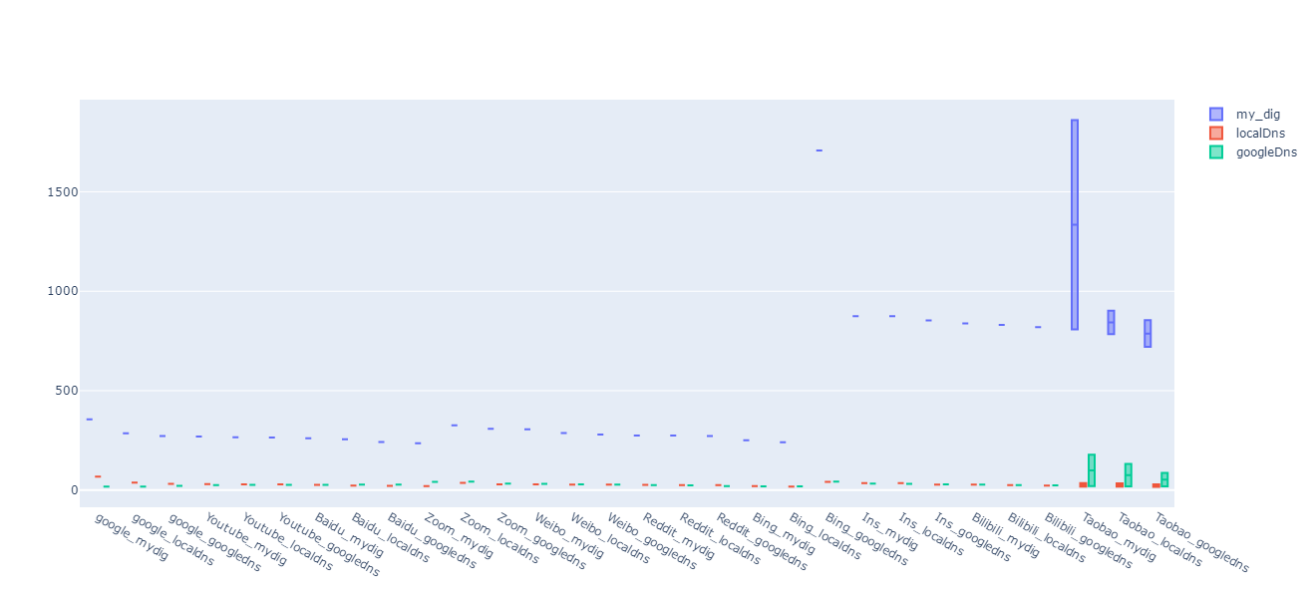

Domain name = ‘Google.com’(input)

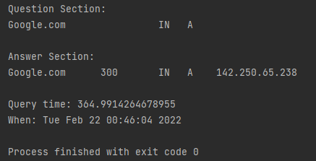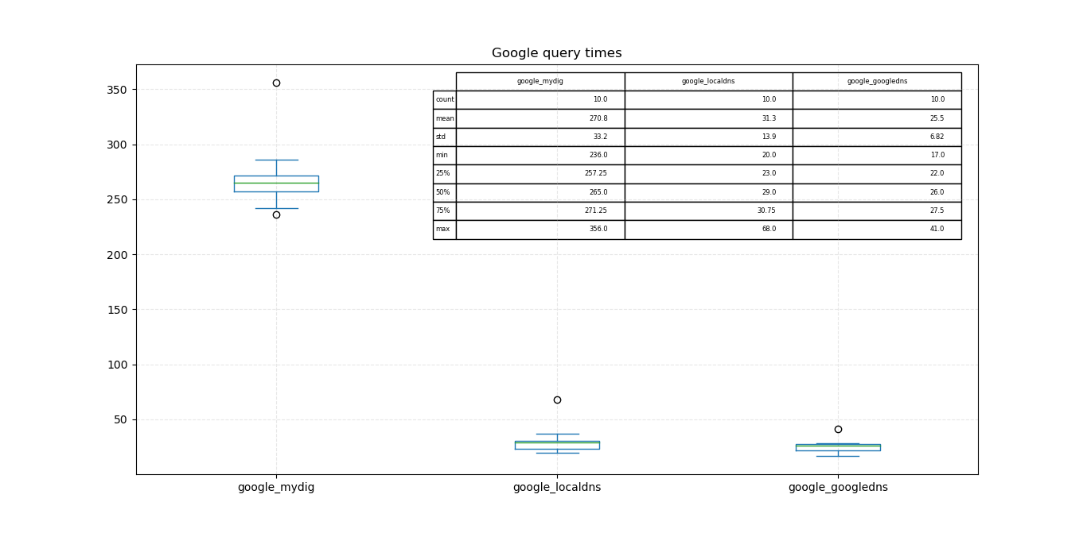

Youtube.com

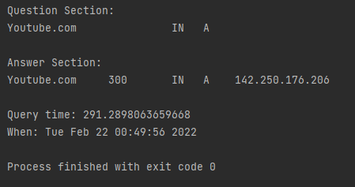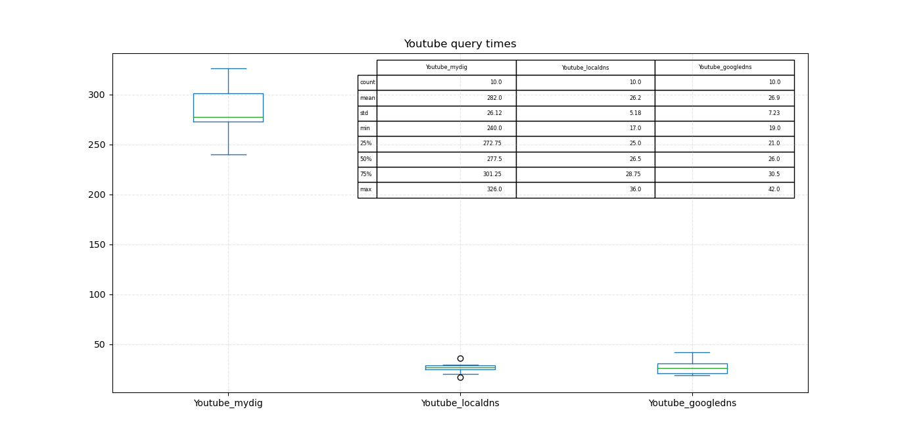

Baidu.com

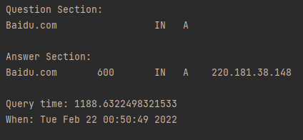

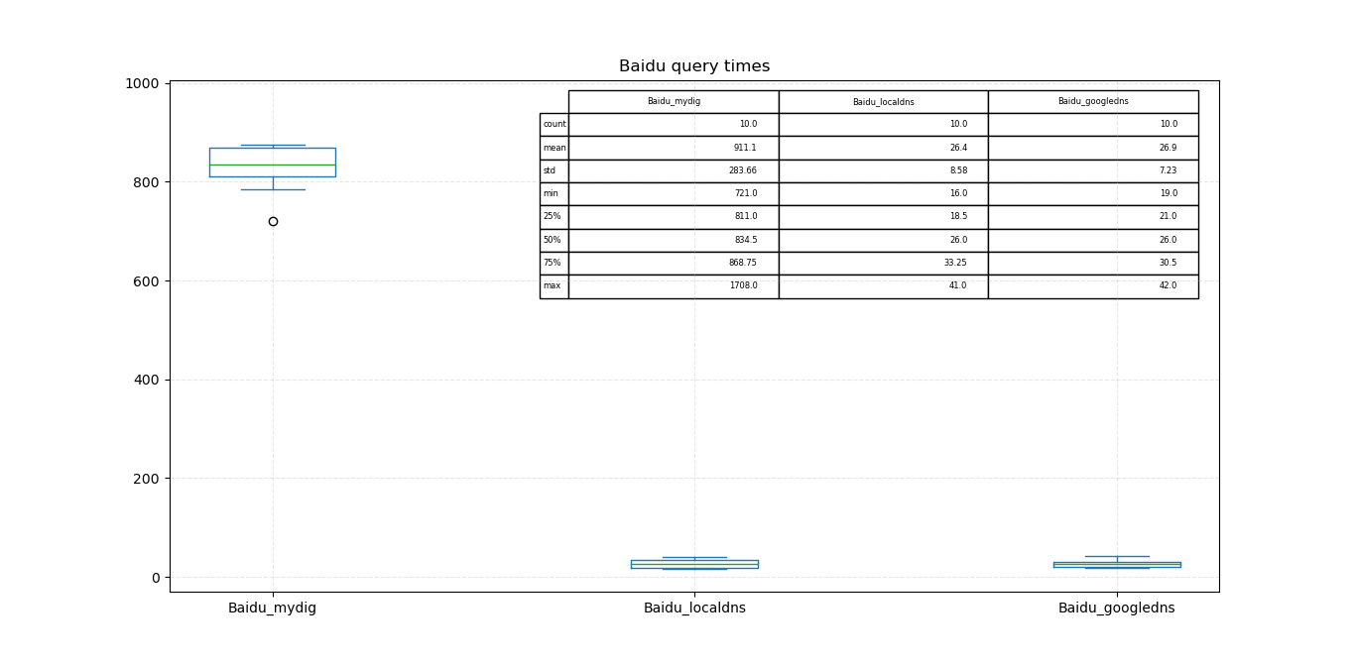Zoom.us

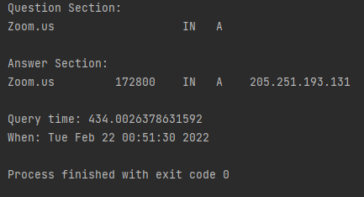

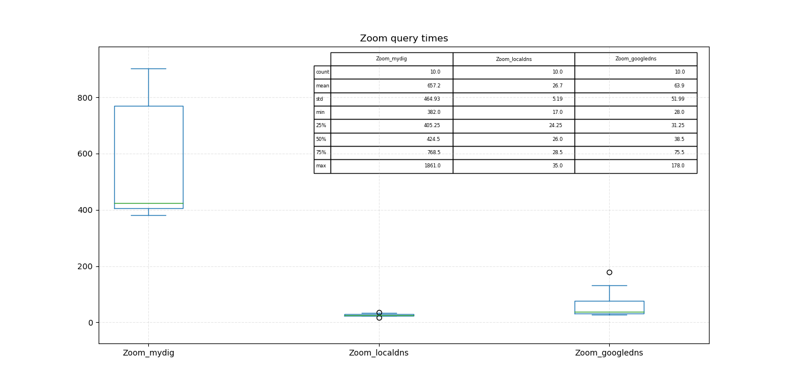

Weibo.com

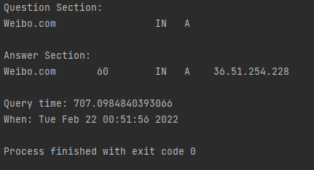

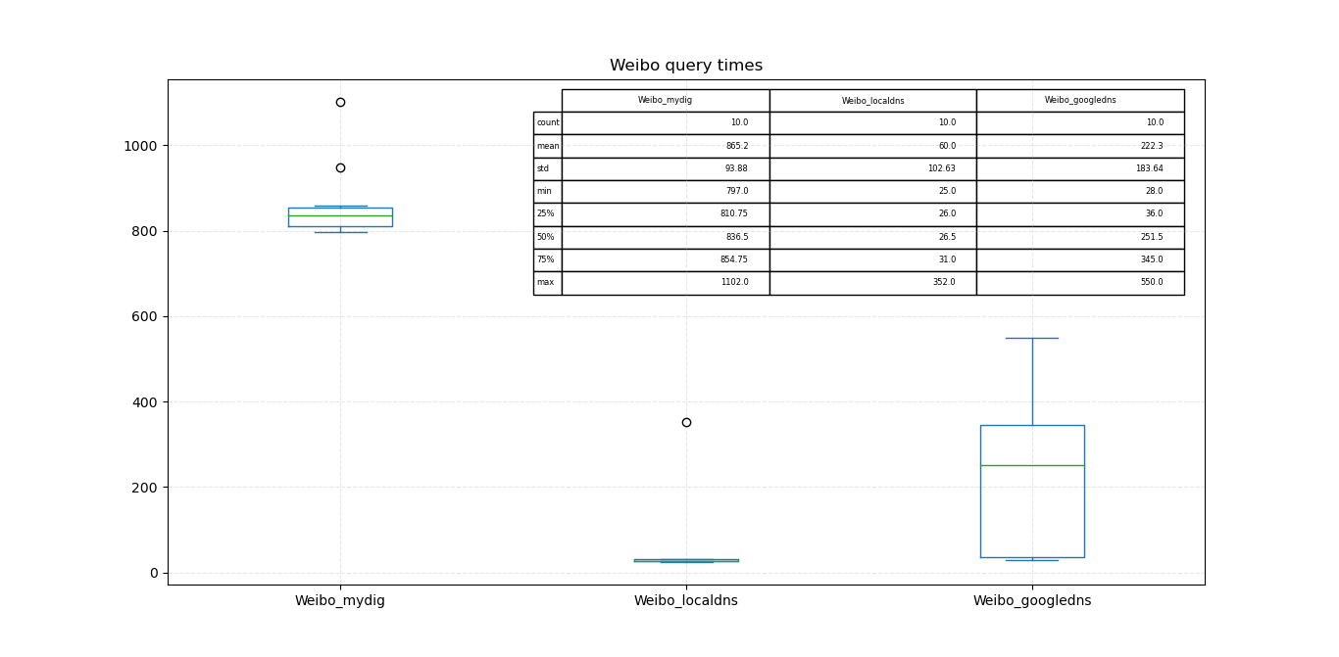Reddit.com

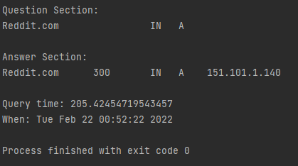

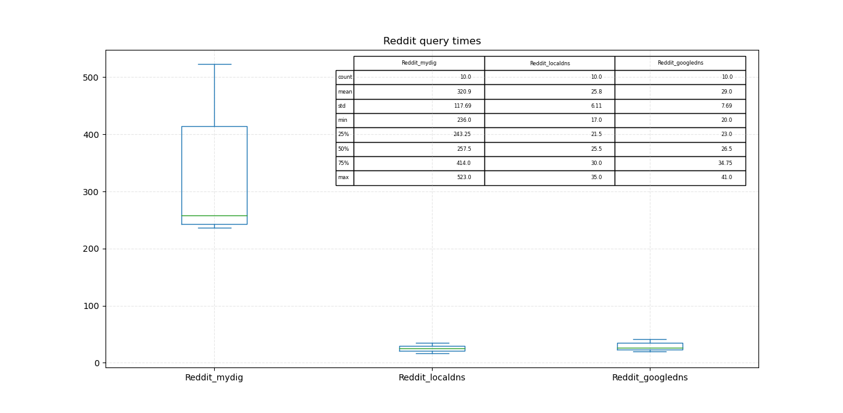Bing.com

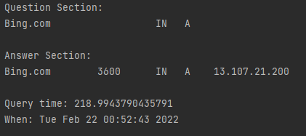

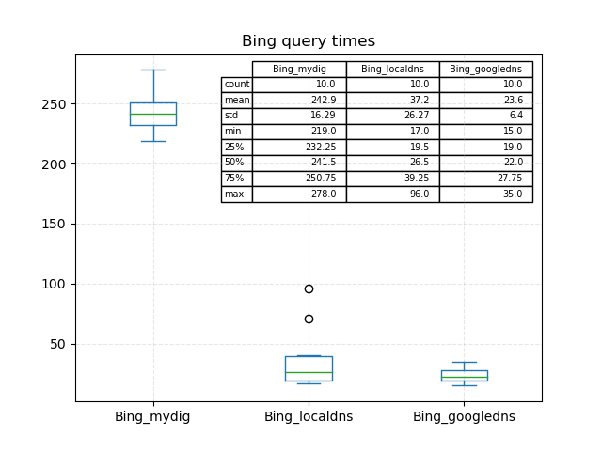

Instagram.com

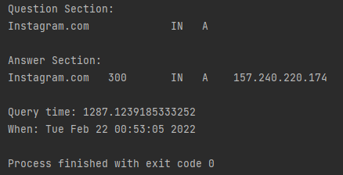

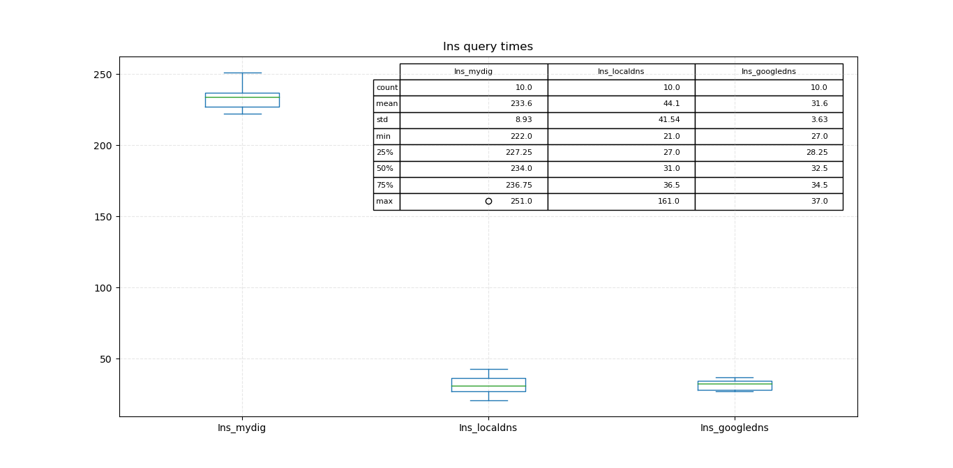Bilibili.com

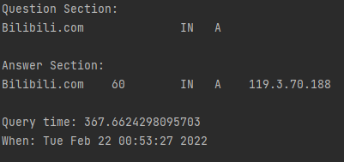

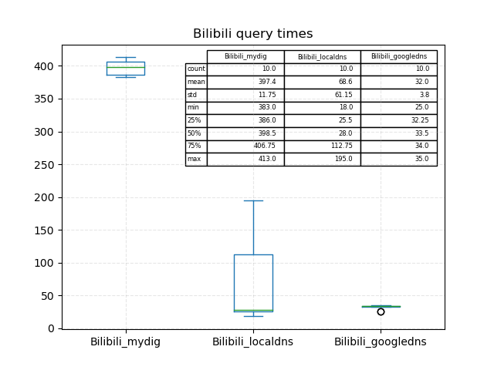

Taobao.com

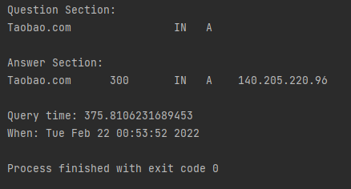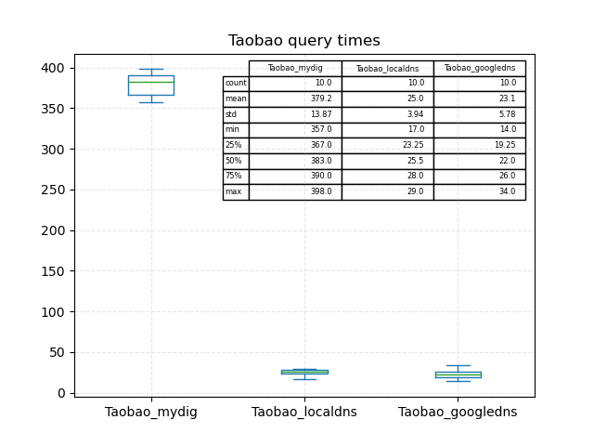

Result analysis:

By observing the query time from resolving DNS by three different ways, I find it always takes the longest time to resolve DNS by my DNS resolver. I analyze this might mainly be caused by two factors. The first one is lacking cache. When the client sends a request, the DNS will search it in its cache at first. If it has local cachet, it will get the information from the cachet without forwards query into a hierarchy. However, the cache is not contained in my program, the query must go through all the hierarchic which might cost lots of time. Another influencing factor might be I choose the TCP protocol. Since UDP creates a socket and connect to the socket but do not establish a connection as TCP, it will be more time-saving.